**WRITING PORTFOLIO 5**

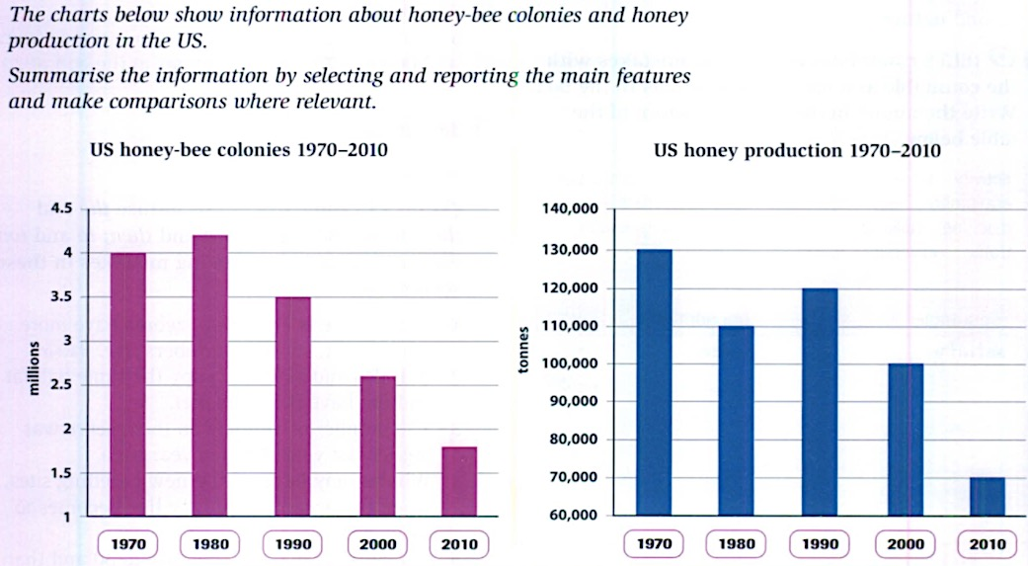

The first char illustrates how many honey bee colonies were in the US from 2010 to 2020 , and the second chart shows the amount of honey which was produced in the US between 2010 and 2020.

In 1970, the honey bee colonies reached 4 millions . From 1970 to 1980, there was a significant go up in the honey bee a haft 4.5 million colonies. However, between 1980 and 2010, the honey bee dropped quickly nearly 2 million colonies

Next to the second chart, in 1970, the honey production about 130,000 tonnes. Over a 10 year period, the honey was producted decreasingly 20,000 tonnes. Ten years later, there was a gradual increase in the honey which producted about 10,000 tonnes, total honey production was 120,000 tonnes. However, between 1990 and 2010, the honey production went down rapidly 70,000 tonnes.

Overall, there was more honey production, there were more honey-bee colonies, but in 1980, the honey production and the honey-bee colonies was opposite. Instead of the number of honey-bee colonies increasing, the honey production is decreasing.